Name: Nnadiekwe Chiderah David

***Deploy Apache HTTP server on Amazon Linux2 instance***

1. Launch a new Amazon Linux 2 EC2 instance on AWS.

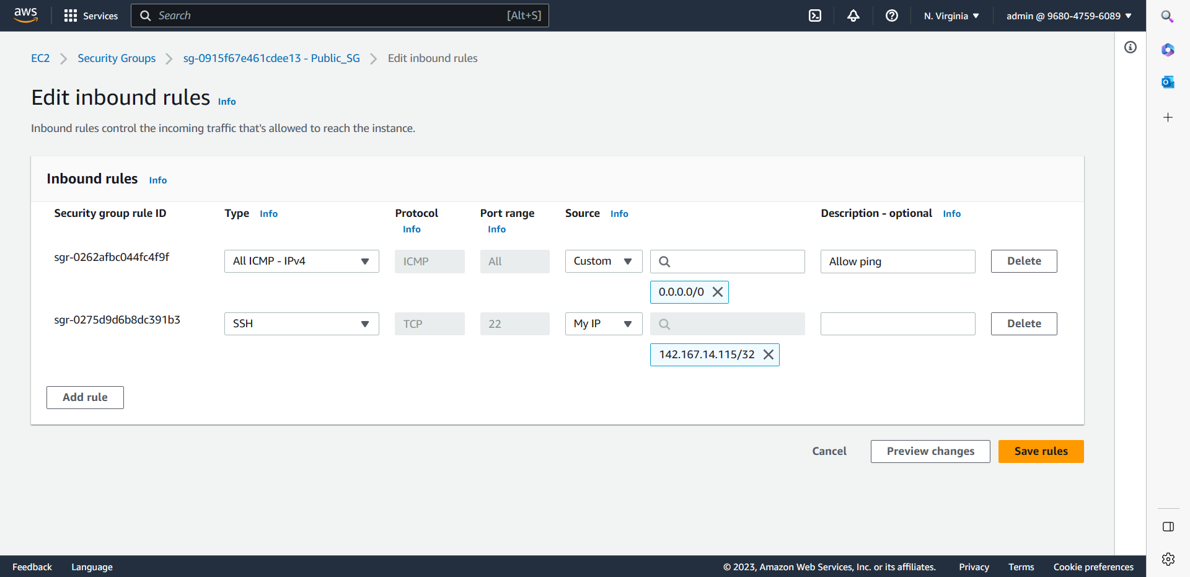

1. Connect to the instance using SSH

1. Install the Apache web server using the following command: sudo yum install httpd

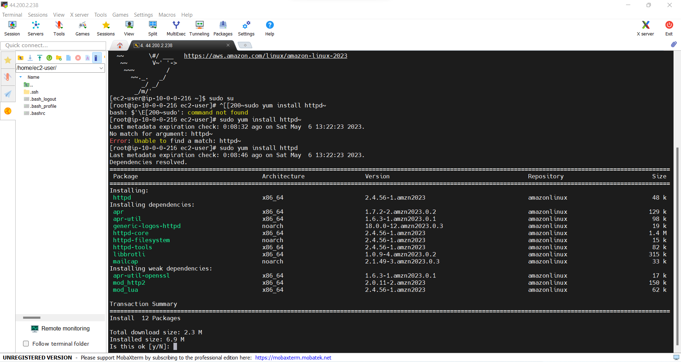

1. Start the Apache service using the following command: sudo service httpd start

1. Verify that Apache is running by browsing to the public IP address of the instance in a web browser.

*I Modified security group to allow HTTP*

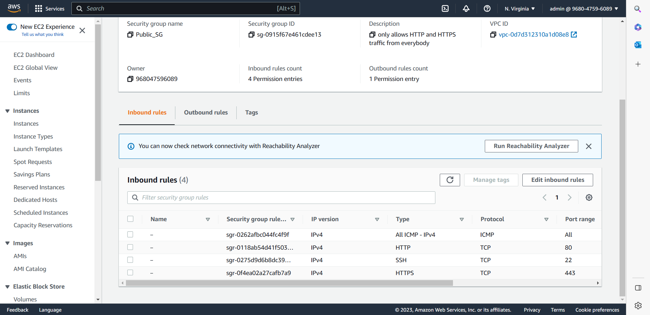

1. Create a simple HTML file displaying website built by student_name and host it on the web server.

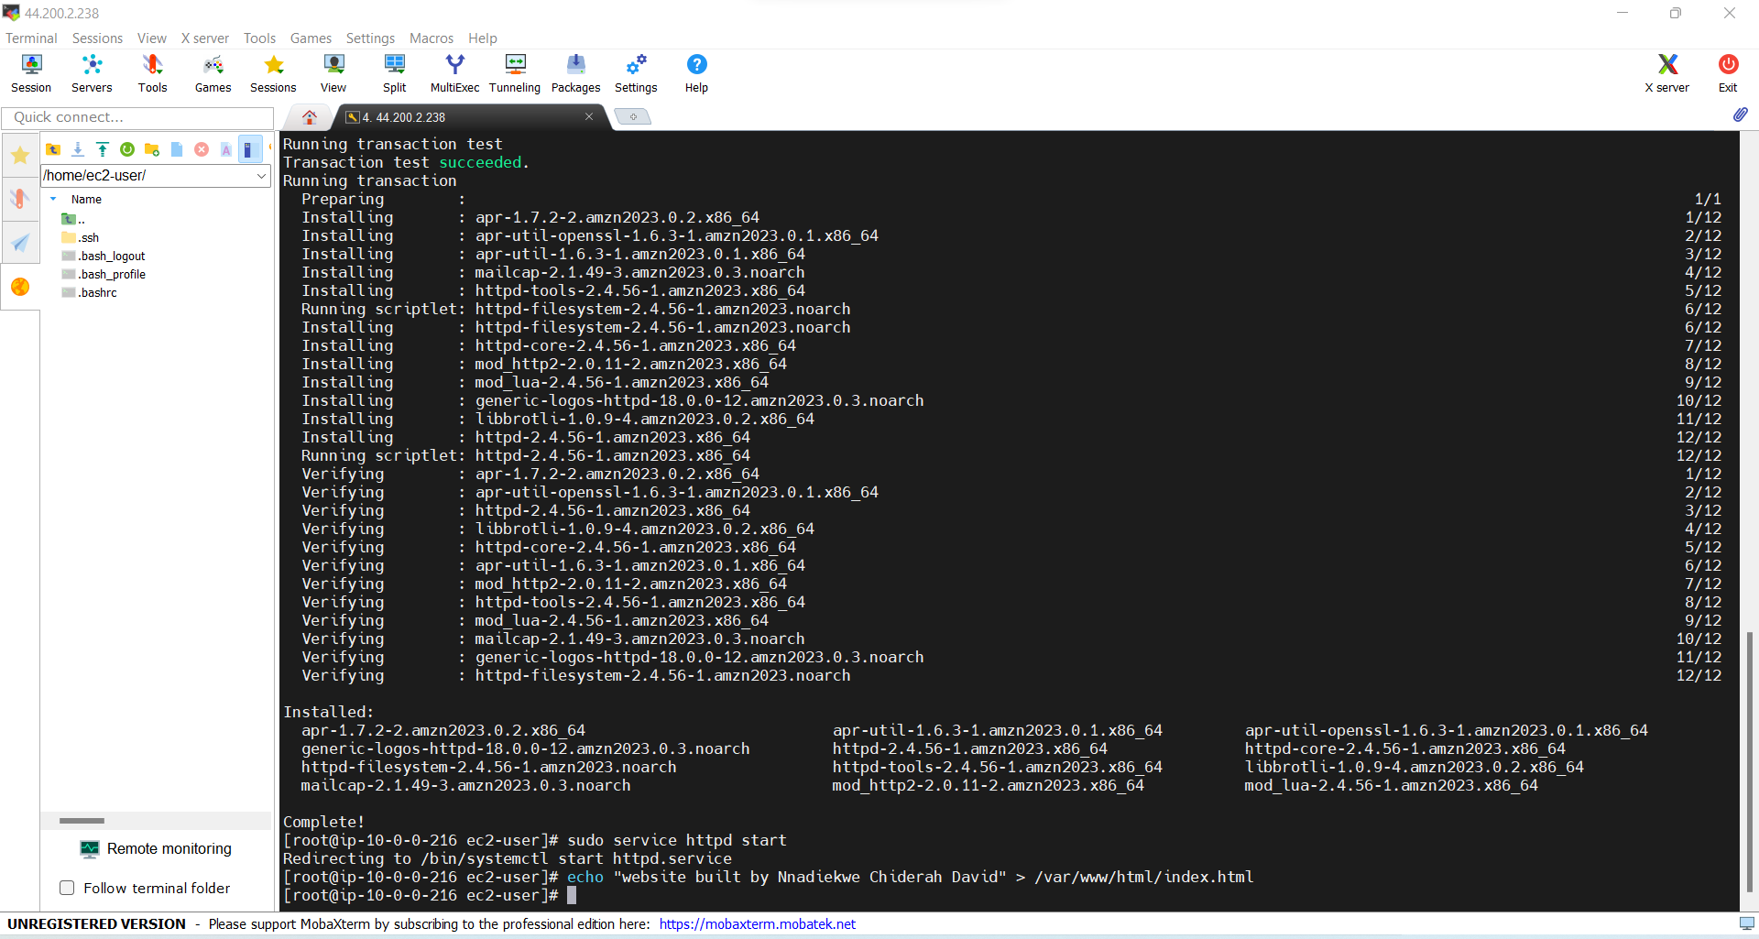

1. Verify that you can access the HTML file by browsing to the public IP address of the instance in a web browser.

